Traffic Sign Recognition

Yi Lee

**Abstract**

In this project, I would implement image recognition with convolution neuro network on traffic sign. In the dataset, it has 43 classes of traffic signs, 39209 training images, and 12630 testing images. Each data is consisted with a (30,30,3) vector, which means each image is 30 pixels * 30 pixels with RGB three channels.

Below is the workflow:

**Neuro Network Construction**

**Input Layer**

**Conv2d**

**Conv2d**

**Max Pool**

**Conv2d**

**Max Pool**

**Conv2d**

**Max Pool**

**Flatten Layer**

**Fully connected Layer**

**Output Layer**

**Hidden Layers**

In brief, Conv2d layer is used to filter the image, to detect the similarity; Max Pool is used to extract the significant data; Flatten Layer is used to turn 2-dimension vector into 1-dimension vector, which is a preparation for the following connected layer. Finally, SoftMax function is being used in Output Layer, it could provide the class of an input image.

**Outcome**

The network finally provides a 98% accuracy on validation data, and 94% accuracy on testing data.

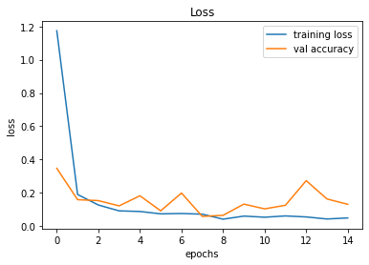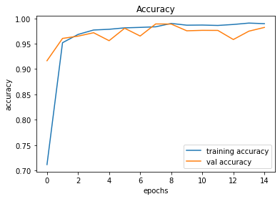

As we can see, the accuracy rises slowly after 6 epochs, which means the model has almost reach the local minimum, which could determine the parameter of the model.

**Weakness**

The model could only recognize the ‘traffic sign’ image only, namely, it can only input the image with only traffic sign in the image.

Here are some examples from the datasets.

  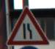 

Therefore, if I input the image like below, the model would provide the wrong answer, because it can’t recognize the image other than the sign only.

|  |  |
| --- | --- |
|  | Speed limit (120km/h) |
|  | Yield |
|  | Priority Road |

**Solution**

A proper solution is implementing a model to crop the image first.

For example, crop only “STOP” sign.

We must let out computer know what a traffic sign is, then let it know how to crop the complete traffic sign without any loss.

Personally, I think it is more complicated, it would require more datasets.